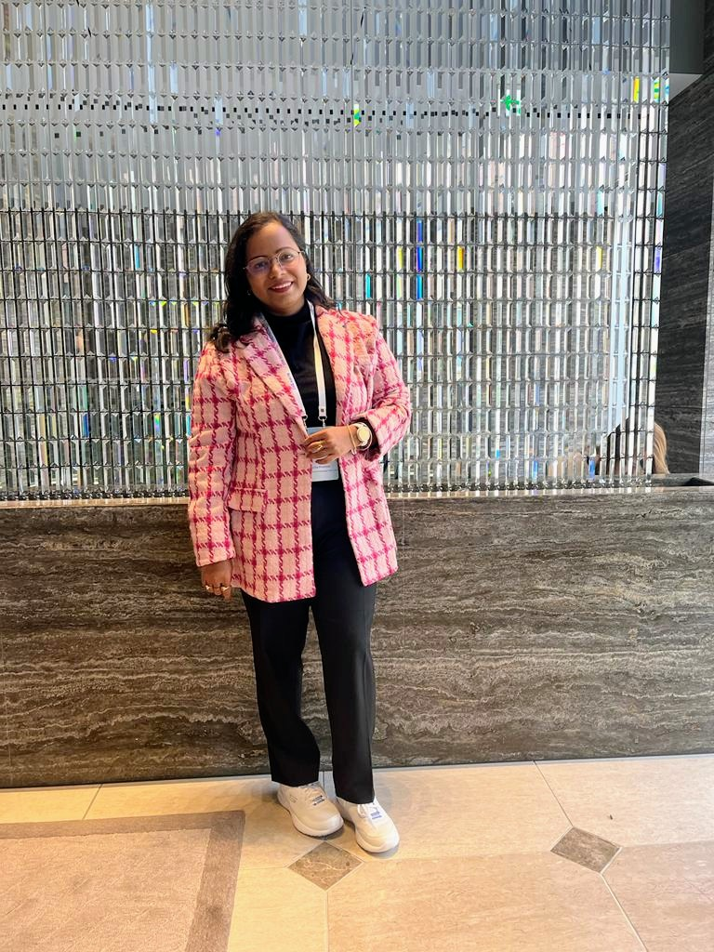

**PhD topic: Development of a green process for the recovery of metals and conversion of e-waste plastic into oil (chemicals)**

**Brief intro:** Amrita is pursuing her PhD from IIT Delhi. She is working on development of green process for the recovery of metals from electronic waste and conversion of e waste plastics into valuable products with different techniques like supercritical fluids, hydrometallurgy, adsorption and others. Her background is chemical engineering and she is skilled in metal extraction, plastic decomposition, experimental design, and several research techniques.

She is jointly supervised by Prof. Vivek Kumar, Prof.K.K.Pant, and Prof.S.N.Naik.

**Google scholar:**

<https://scholar.google.co.in/citations?user=qMAVC_oAAAAJ&hl=en&oi=ao>

**LinkedIn:** <https://www.linkedin.com/in/amrita-preetam-385705a3/>